Strategic Opportunity Profile
Company Name |  |  |  |  |  |  |  | Date
Phone |  | Website
Primary Contact |  |  |  |  |  |  | e-mail
Divisions/Departments |  |  |  |  |  |  | Number of Employees
 |  |  |  |  |  |  | Annual Revenue
Staffing Scope
Scope/Number of Openings | Time Frame |  |  |  | Average Rate/Position |  |  |  | Total Fee Potential
Stages of the Client Decision Process
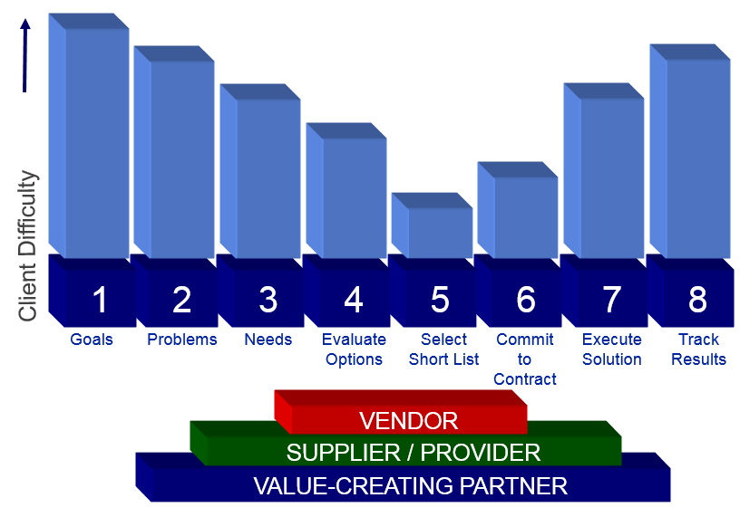

Where is my prospect/client in the decision process?

What value can I potentially bring at this stage?

How the company is perceived by its industry and market:
History/ Business:
Competitive Position:
Key Qualifying Criteria
Goals/Objectives/Timing: How can I align solutions to help achieve the client’s goals?

Challenges/Timing: How can I align solutions to resolve the client’s problems or issues?

Needs/Timing: How can I align solutions to meet the client’s needs?

Decision/Timing: In addition to my primary contact, who else is involved in the decision-making process?

Financial Factors/Timing:

Competition/Client Options/Timing:

Does the potential with this account justify a face-to-face presentation?
1 2 3 4 5
I have a thorough understanding of my client’s goals and objectives.
My client has a sense of urgency around staffing initiatives.
I know where the client is in his/her decision process. I have the cooperation and respect of at least one hiring authority who
will work with me to move the process forward.
I have clear objectives, strategy and agenda for my client meeting.
What resources will I need to fill these positions?
Project Coordinators
Advertising/Social Media Tools
Outside Partners
Expanded Team
Key Player Profile
Primary Relationship  Name:  Position:  Advocate Neutral Adversary |  |  | Decision Maker |  |  | Decision Influencer |  |  |  | Financial Evaluator
Other Key Relationships
Name:
Position:
Advocate Neutral Adversary
Name:
Position:
Advocate Neutral Adversary
Name:
Position:
Advocate Neutral Adversary
Profile of Primary Relationship
How is his/her performance evaluated?
By whom is he/she evaluated?
Employment history at client company
Whom or what does this individual influence? |  |  |  | Who influences this key player?
Orientation of primary relationship
Avoids risk Seeks reward
Logical Emotional
Short-term focus Long-term focus
Initial Recommendations / Guiding Suggestions

Anticipated Resistance

Call Plan
Name of Organization
Address | Phone
Current Status of Account | Date of Call
Current Status of Account | Meeting Scheduled With
Current Status of Account | Time Requested/Scheduled
Objectives of Call:
Introduce:

Insight:

Inquire:

Inspire:

Invest:

Additional Notes:

